**Fundamentals of Data Science**

**The British College**

**Bi-weekly Assignment Solutions (Week 1 & 2)**

**Student Name:** Praful Tiwari  
**Module:** Fundamentals of Data Science  
**Module Code:** UFCFK1-15-0  
**Tutor:** Saurav Gautam  
**Academic Year:** 2024-2025

### 1. Diagram: How Python Works

### 2. Program: Basic Arithmetic Operations

**Description:** This program inputs two numbers from the user and performs arithmetic operations such as addition, subtraction, multiplication, division, modulo division, and floor division.

# Program to perform arithmetic operations on two numbers  
  
num1 = float(input("Enter first number: "))  
num2 = float(input("Enter second number: "))  
  
print("Addition:", num1 + num2)  
print("Subtraction:", num1 - num2)  
print("Multiplication:", num1 * num2)  
print("Division:", num1 / num2)  
print("Modulo Division:", num1 % num2)  
print("Floor Division:", num1 // num2)

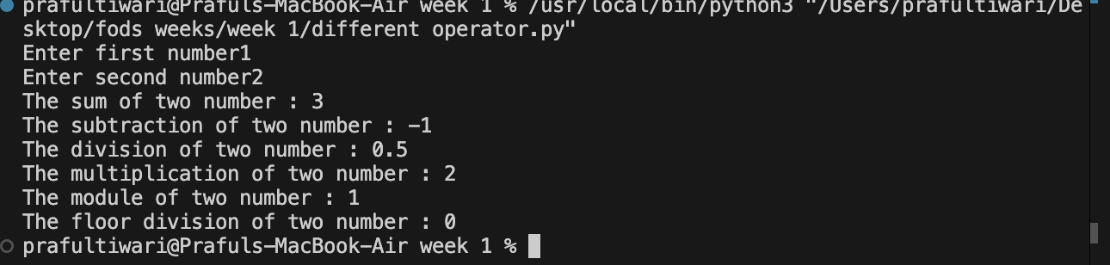

### 3. Program: Even or Odd

**Description:** This program checks if the entered number is even or odd.

# Check whether a number is even or odd  
  
number = int(input("Enter a number: "))  
  
if number % 2 == 0:  
 print("The number is Even")  
else:  
 print("The number is Odd")

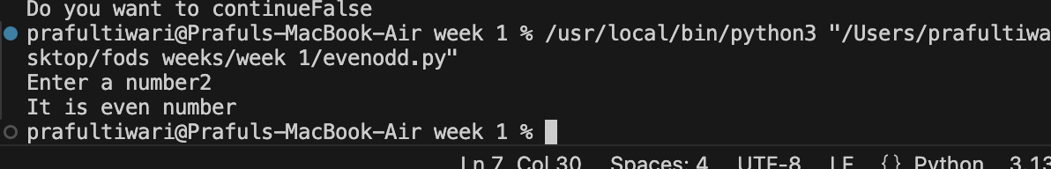

### 4. Program: Mathematical Calculations

**Description:** This program computes square, square root, exponent, logarithm base 10, and powers 3, 4, and 5.

# Perform mathematical calculations  
  
import math  
num = float(input("Enter a number: "))  
  
print("Square:", num**2)  
print("Square Root:", math.sqrt(num))  
print("Exponent (e^x):", math.exp(num))  
print("Log base 10:", math.log10(num))  
print("Power 3:", num**3)  
print("Power 4:", num**4)  
print("Power 5:", num**5)

### 5. Program: Algebraic Expressions

**Description:** This program calculates results of various algebraic expressions.

# Solve algebraic expressions  
  
a = int(input("Enter a: "))  
b = int(input("Enter b: "))  
c = int(input("Enter c: "))  
  
print("a^2 + 2ab + b^2 =", a**2 + 2*a*b + b**2)  
print("a^5 + 2abc + b^3 + c^4 =", a**5 + 2*a*b*c + b**3 + c**4)  
print("a^7 + 5a^3b^2c^6 + b^7 =", a**7 + 5*a**3*b**2*c**6 + b**7)

### 6. Program: Student Result Calculation

**Description:** Calculates average, percentage, and division based on 5 subject marks.

# Calculate result of 5 subjects  
  
marks = []  
for i in range(5):  
 marks.append(float(input(f"Enter marks of subject {i+1}: ")))  
  
total = sum(marks)  
average = total / 5  
percentage = (total / 500) * 100  
  
print("Total:", total)  
print("Average:", average)  
print("Percentage:", percentage)  
  
if percentage >= 80:  
 division = "Distinction"  
elif percentage > 60:  
 division = "First Division"  
elif percentage > 50:  
 division = "Second Division"  
elif percentage > 45:  
 division = "Third Division"  
else:  
 division = "Fail"  
  
print("Division:", division)

### 7. Program: Prime Numbers in Range

**Description:** Finds and sums prime numbers in a given range.

# Find prime numbers and their sum  
  
start = int(input("Enter start number: "))  
end = int(input("Enter end number: "))  
  
sum_primes = 0  
  
for num in range(start, end+1):  
 if num > 1:  
 for i in range(2, int(num**0.5)+1):  
 if num % i == 0:  
 break  
 else:  
 print(num, end=" ")  
 sum_primes += num  
  
print("\nSum of prime numbers:", sum_primes)

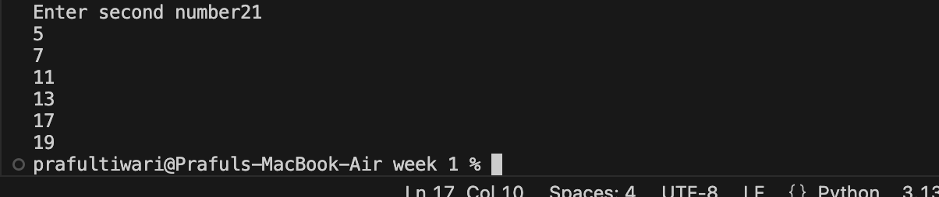

### 8. Program: Divisible by 7 but not 5

**Description:** Finds numbers divisible by 7 and not by 5 between user-defined range.

# Numbers divisible by 7 but not by 5  
  
start = int(input("Enter start number: "))  
end = int(input("Enter end number: "))  
  
for i in range(start, end+1):  
 if i % 7 == 0 and i % 5 != 0:  
 print(i, end=", ")

### 9. Program: Factorial with Validation

**Description:** Calculates factorial if input is a valid number.

# Calculate factorial with input validation  
  
num = input("Enter a number: ")  
  
if num.isdigit():  
 num = int(num)  
 factorial = 1  
 for i in range(1, num+1):  
 factorial *= i  
 print("Factorial:", factorial)  
else:  
 print("Not a number.")

### 10. Program: Sum of Odd and Even Numbers

**Description:** Menu-driven program to sum odd and even numbers.

# Sum of odd and even numbers  
  
even_sum = 0  
odd_sum = 0  
  
while True:  
 num = int(input("Enter a number: "))  
 if num % 2 == 0:  
 even_sum += num  
 else:  
 odd_sum += num  
   
 choice = input("Do you want to continue? (yes/no): ")  
 if choice.lower() != 'yes':  
 break  
  
print("Sum of even numbers:", even_sum)  
print("Sum of odd numbers:", odd_sum)

### 11. Program: Number Guessing Game

**Description:** Game that allows user to guess a number within 5 tries.

# Number Guessing Game  
  
import random  
  
answer = random.randint(1, 100)  
  
for i in range(5):  
 guess = int(input("Guess the number: "))  
 if guess < answer:  
 print("Too low")  
 elif guess > answer:  
 print("Too high")  
 else:  
 print("Correct number!")  
 break  
else:  
 print("Game Over")

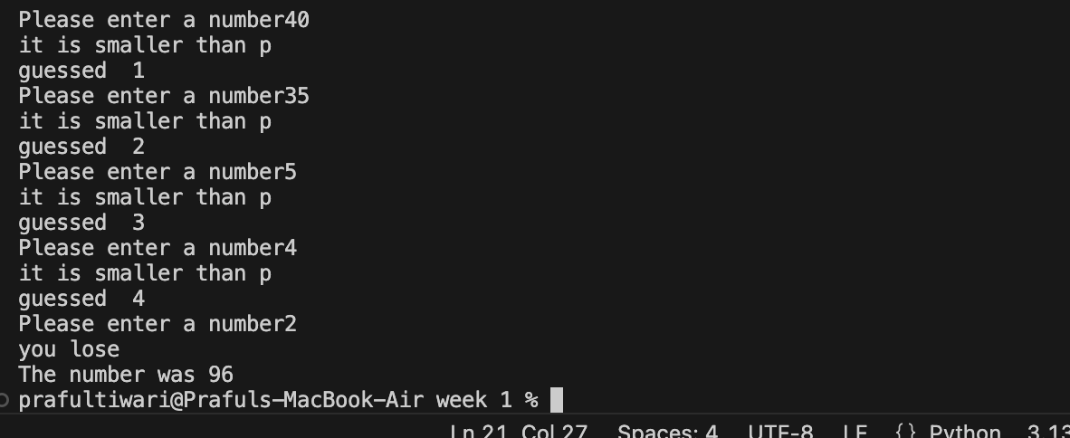

**End of Assignment 1 Solution**